**Introduction to proteus, schematic capture and PCB layout**

**Lab no #01**

** Fall 2019**

**Spring 2021**

**Electronic Circuit-Lab**

Submitted by: **Ashfaq Ahmad**

Registration No: **19PWCSE1795**

Class Section: **B**

“On my honor, as student of University of Engineering and Technology, I have neither given nor received unauthorized assistance on this academic work.”

Student Signature: ______________

Submitted to:

**Engr. Abdullah hameed**

April 16, 2021

**Department of Computer Systems Engineering**

**University of Engineering and Technology, Peshawar**

**Objectives:**

After taking this lab, we will be able

* To know how to install proteus software.
* To know its uses and its functionality.
* To know about schematic capture and how to design a circuit in schematic capture.
* To know about PCB layout and how we design a circuit in PCB layout.

**Introduction:**

* **Proteus**is used to simulate, design and drawing of electronic circuits. It was invented by the Lab center electronic.
* By using proteus We can make two-dimensional circuits designs as well.
* With the use of this engineering software, we can construct and simulate different electrical and electronic circuits on our personal computer or laptops.

**HOME screen of proteus:**

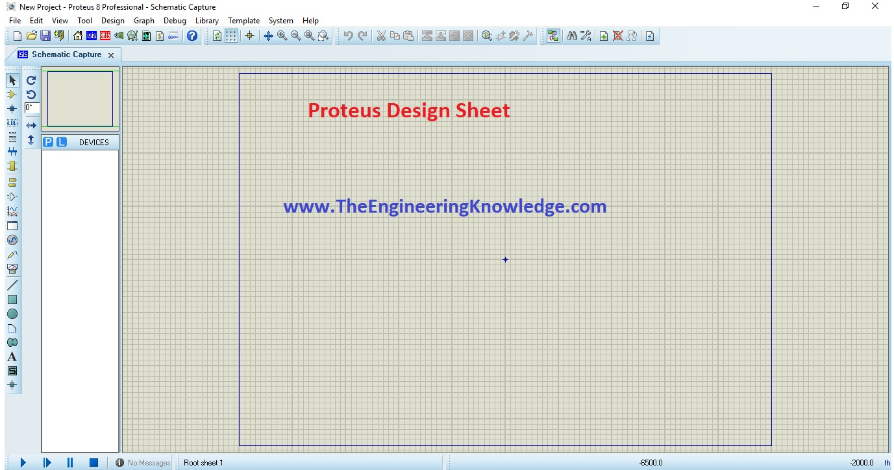

**Advantages:**

* Designing of circuits on the proteus takes less time than practical construction of the circuit.
* The possibility of error is less in software simulation such as loose connection that takes a lot of time to find out connections problems in a practical circuit.
* Circuit simulations provide the main feature that some components of circuits are not practical then you can construct your circuit on proteus.
* There is zero possibility of burning and damaging of any electronic component in proteus.
* The electronic tools that are very expensive can easily get in proteus such as an oscilloscope.
* Using proteus you can find different parents of circuits such as current, a voltage value of any component and resistance at any instant which is very difficult in a practical circuit.

**How to Make Circuit in Proteus**

* We will perform some steps to make a circuit.

**Step 1**:

* First of all click on proteus Icon in your computer and click on a new file option as shown in the below figure.

[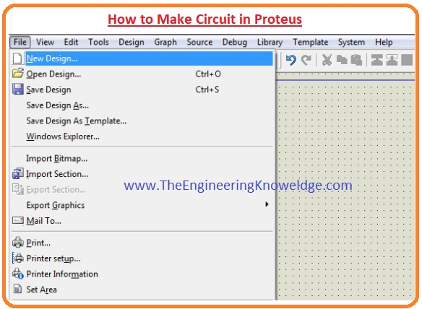](https://www.theengineeringknowledge.com/wp-content/uploads/2020/01/How-to-Make-Circuit-in-Proteus.jpg)

**Step 2:**

* After that, you will see the drawing sheet as shown in the below figure. Save it according to your project.



**Step 3:**

* After a move to the component option as shown in the below figure and select the elements for your projects.
* 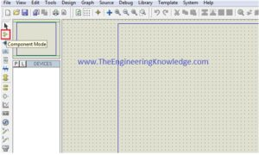

**Step 4**:

* After clicking on components mode you will see two buttons P and L. If you move to P button you will see Pic from Libraries.
* It is used to select different components for circuit construction.

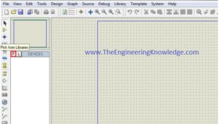

**Step 5:**

* When you will click on the P button you will see box shown in the below figure. Type your component for a circuit.
* As I type button and you can see a button in right figure that different buttons are shown you can select according to your use.

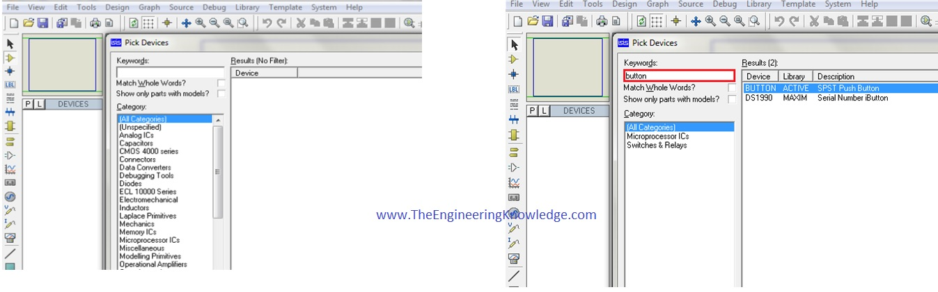

**Step 6:**

* When you will select components for your project you will see them in a box shown in the below figure.
* I have also selected some components for designing of a simple circuit.

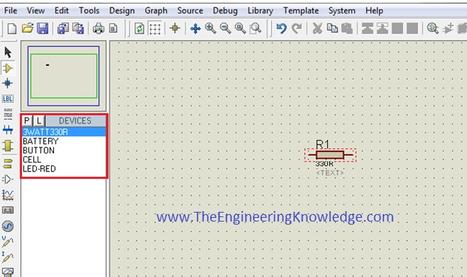

* After the selection of components make the circuit layout of your project and connect all these components with the wires.
* For connection of one component to other clicks left of first one terminal of component and drag it to other components.
* If you want to remove any component or remove its connection just double click on respective of a component of wire.

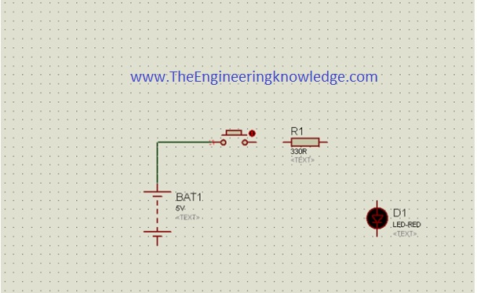

* If you want to change the values of any component such as resistance, capacitor, then click right on that component and select the desired value and click OK button.
* As in the below figure, I vary the value of battery voltages.

[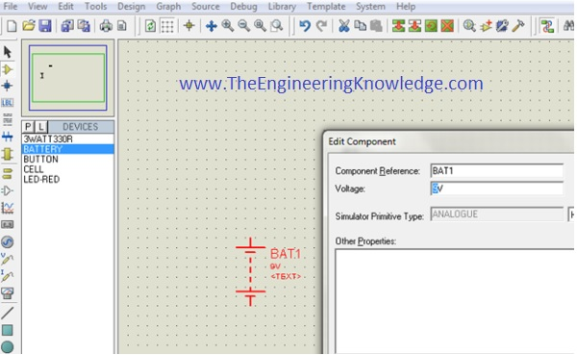](https://www.theengineeringknowledge.com/wp-content/uploads/2020/01/Component-Properties-Edit.jpg)

**Step 7:**

* When you connect all components in the circuit like run button in left bottom see the practical working of your circuit**.**

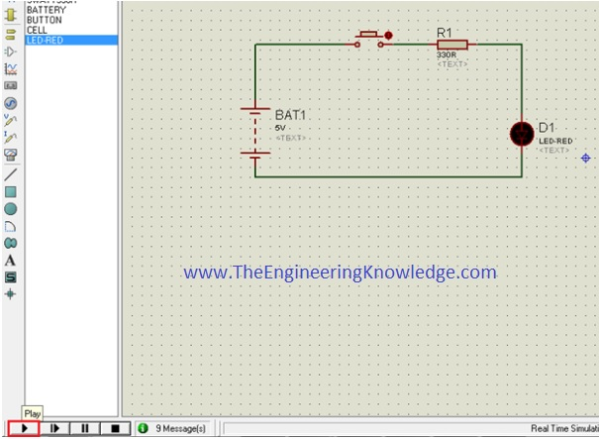

**Step 8:**

* When you will observe the simulation of your circuit than click on stop button on the left bottom to stop the working of the circuit.

**Features of Proteus**

* There are 2 main parts of proteus first is used to design schematic capture I,e draw different circuits and the second is for designing of PCB layout.
* First is ISIS that used to design and simulate circuits. And second is ARES that used for designing of a printed circuit board.
* It also provides features related to the three-dimensional view of design in PCB.

**Schematic capture:**

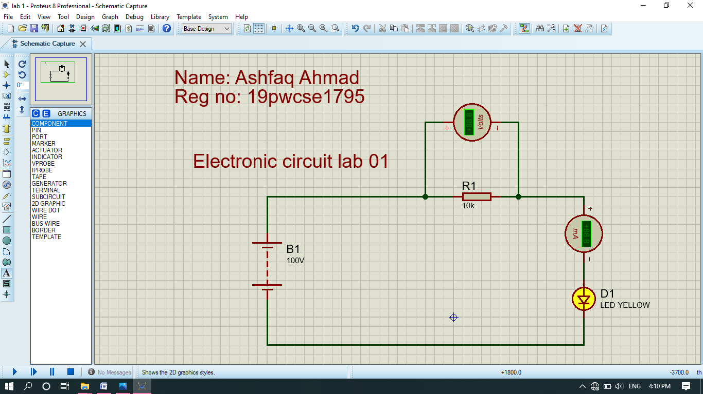

**PCB layout:**

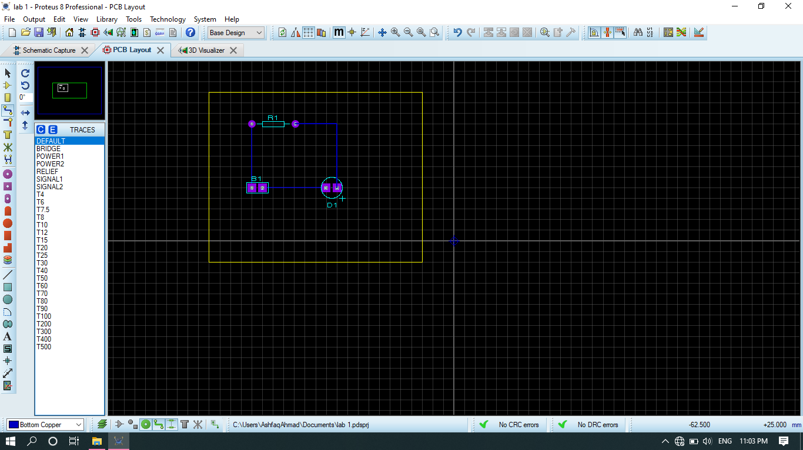

**3-D visualizes:**

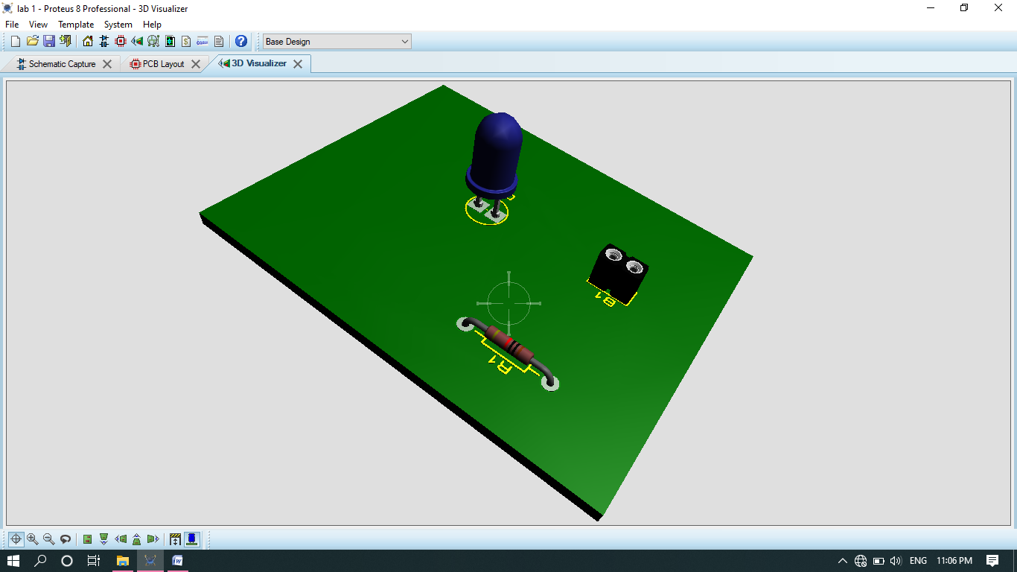

**Backside:**

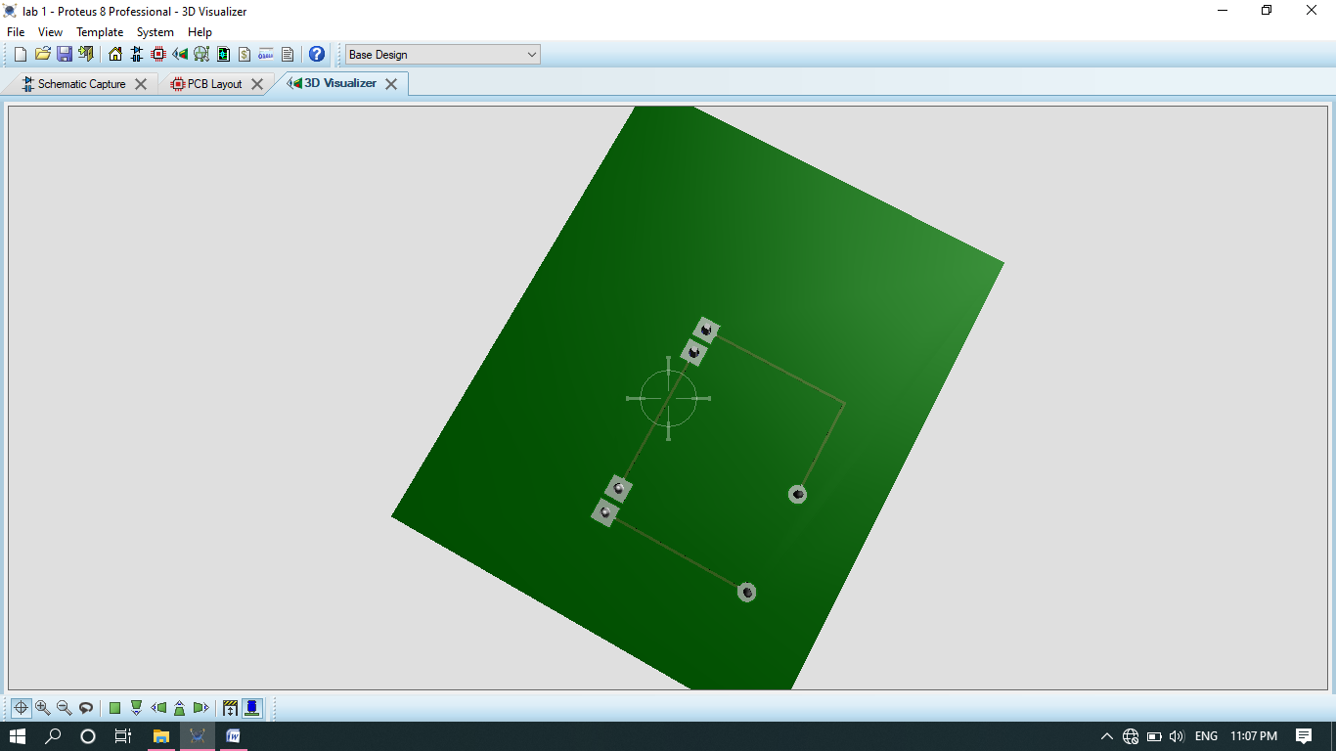

**THE END**